Python Coding Test Submission
- Submitted by: Venketesh Pratap Mall
- Date: February 4, 2026
- GitHub Repository: https://github.com/VenketeshPratap/aus_public_holiday_v2

Folder Structure-
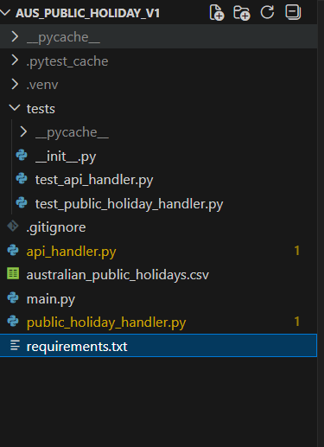
• Running python main.py
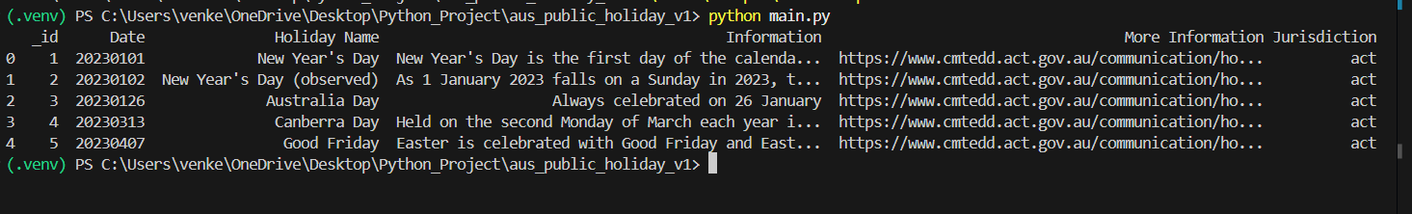

• Running pytest -v
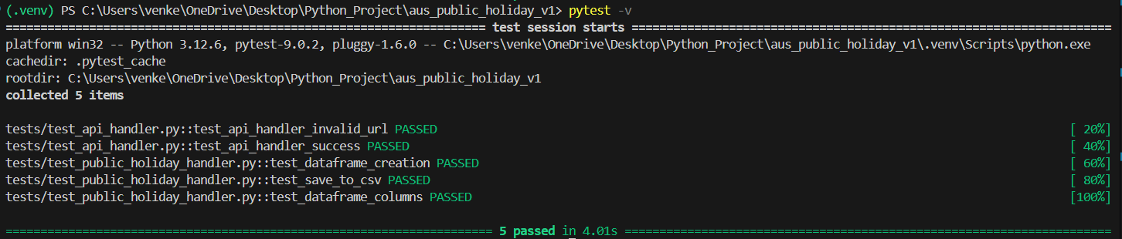

Saved the full table as CSV in the same folder.
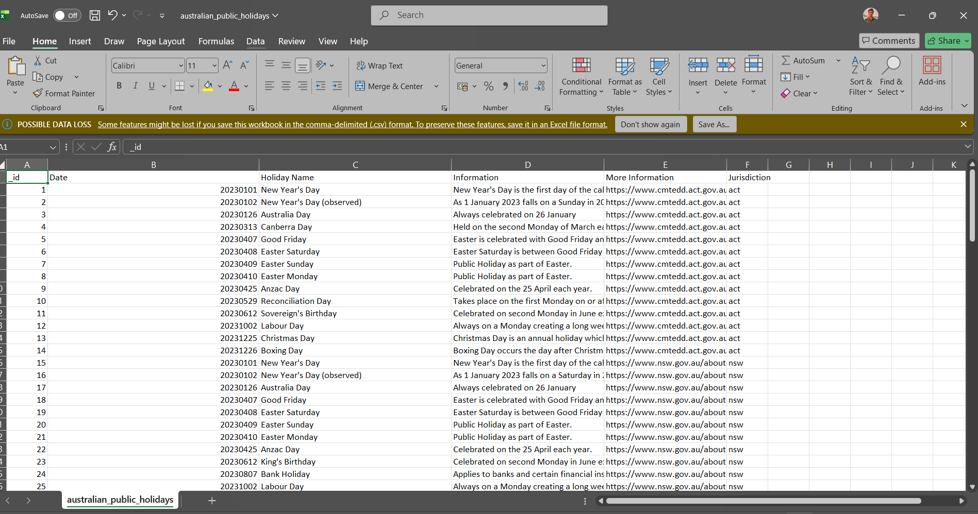

Api_handler.py
import requests
from typing import Dict, Any

class APIHandler:
"""
Handles communication with the Australian Government CKAN API.
"""

def __init__(self, base_url: str):
"""
Initialize APIHandler with base API URL.

:param base_url: Base CKAN API URL
"""
self.base_url = base_url.rstrip("/")

def fetch_data(
self, resource_id: str, limit: int
) -> Dict[str, Any]:
"""
Fetch data from CKAN datastore_search endpoint.

:param resource_id: CKAN resource ID
:param limit: Number of rows to retrieve
:return: JSON response
"""
url = f"{self.base_url}/datastore_search"
params = {
"resource_id": resource_id,
"limit": limit,
}

response = requests.get(url, params=params, timeout=10)

if response.status_code != 200:
raise RuntimeError("Failed to fetch data from API")

data = response.json()

if not data.get("success"):
raise RuntimeError("API returned unsuccessful response")

return data

public_holiday_handler.py
import pandas as pd
from api_handler import APIHandler
class PublicHolidayHandler:
"""
Prepares public holiday data for analysis.
"""
def __init__(
self,
api_handler: APIHandler,
resource_id: str,
limit: int = 1000,
):
"""
Initialize handler and retrieve public holiday data.
:param api_handler: APIHandler instance
:param resource_id: CKAN resource ID
:param limit: Number of rows to fetch
"""
try:
self.raw_data = api_handler.fetch_data(
resource_id=resource_id,
limit=limit,
)
except Exception as exc:
raise RuntimeError(
"Failed to retrieve public holiday data"
) from exc

def to_dataframe(self) -> pd.DataFrame:
"""
Convert public holiday JSON data to Pandas DataFrame.

:return: Pandas DataFrame
"""
records = self.raw_data["result"]["records"]
return pd.DataFrame(records)

def save_to_csv(self, file_path: str) -> None:
"""
Save public holiday data as CSV.

:param file_path: Output CSV file path
"""
df = self.to_dataframe()
df.to_csv(file_path, index=False)

Main.py
from api_handler import APIHandler
from public_holiday_handler import PublicHolidayHandler

def main():
BASE_URL = "https://data.gov.au/data/api/action"
RESOURCE_ID = "d256f989-8f49-46eb-9770-1c6ee9bd2661"

api_handler = APIHandler(BASE_URL)

holiday_handler = PublicHolidayHandler(
api_handler=api_handler,
resource_id=RESOURCE_ID,
limit=1000,
)

df = holiday_handler.to_dataframe()

# Print first 5 rows
print(df.head())

# Save full table as CSV
holiday_handler.save_to_csv(
"australian_public_holidays.csv"
)

if __name__ == "__main__":
main()

Unit- Test
Tests/test_api_handler.py
import pytest
import requests
from api_handler import APIHandler

def test_api_handler_invalid_url():
api_handler = API Handler("https://test-url")

with pytest.raises(Exception):
api_handler.fetch_data(
resource_id="dummy",
limit=5,
)

def test_api_handler_success(monkeypatch):
"""
Test that APIHandler returns JSON data on successful API call.
"""

class MockResponse:
status_code = 200

def json(self):
return {"success": True, "result": {"records": []}}

def mock_get(*args, **kwargs):
return MockResponse()

monkeypatch.setattr(requests, "get", mock_get)

api_handler = APIHandler("https://fake-url")
data = api_handler.fetch_data("dummy", limit=5)

assert data["success"] is True

tests/test_public_holiday_handler.py
import pandas as pd
from public_holiday_handler import PublicHolidayHandler

class MockAPIHandler:
def fetch_data(self, resource_id, limit):
return {
"success": True,
"result": {
"records": [
{"date": "2024-01-01", "name": "New Year"},
{"date": "2024-01-26", "name": "Australia Day"},
]
},
}

def test_dataframe_creation():
handler = PublicHolidayHandler(
api_handler=MockAPIHandler(),
resource_id="dummy",
limit=2,
)

df = handler.to_dataframe()

assert isinstance(df, pd.DataFrame)
assert len(df) == 2

def test_save_to_csv(tmp_path):
"""
Test that CSV file is created successfully.
"""

class MockAPIHandler:
def fetch_data(self, resource_id, limit):
return {
"success": True,
"result": {
"records": [
{"date": "2024-01-01", "name": "New Year"}
]
},
}

handler = PublicHolidayHandler(
api_handler=MockAPIHandler(),
resource_id="dummy",
limit=1,
)

file_path = tmp_path / "holidays.csv"
handler.save_to_csv(str(file_path))

assert file_path.exists()

def test_dataframe_columns():
"""
Test that expected columns exist in DataFrame.
"""

class MockAPIHandler:
def fetch_data(self, resource_id, limit):
return {
"success": True,
"result": {
"records": [
{"date": "2024-01-01", "name": "New Year"}
]
},
}

handler = PublicHolidayHandler(
api_handler=MockAPIHandler(),
resource_id="dummy",
limit=1,
)

df = handler.to_dataframe()

assert "date" in df.columns
assert "name" in df.columns

